# Scope:

Problem: focus on 1 aspect, and provide a few specific examples:

Solution: good if general(can apply to all similar services) , but the final design has to focus on a particular kind of service

Reduce memory load of remembering an entire list of available cards

Navigation design

1. Problem framing

* Target user: anyone who finds the process troublesome, inefficent and cumbersome.
* users with specific aim but uncertain of which product or services to choose??
* Situation: perform multi-step procedural task; choosing a product or enrolling a serving (How dissimilar it is from buying a book in Amazon)
* Platform: desktop website
* Example: bank card (product), travel visa (service)
* Design principles breached:
  + Prioritisation of information based on target audience
  + Filter unnecessary information from specific audience
  + Interactivity in toggling between overview and details
  + Visibility, grouping and ordering of steps for task completion
  + Shortcuts for frequently used functions
  + Low click distance, new windows, and new downloads
* Adjectives describing the problem:
  + Low discoverability
  + Low learnability
  + User-hostile
  + Redundant
  + Non-systematic
  + Tedious, cumbersome, frustrating
* Constraints:
  + Accommodate large amount of data
  + Tailor to multiple groups of users
  + May not be able to classify users into convenient groups
* Needs:
  + Leave a user-centric impression
  + Low error
  + Low cost
  + Fast speed
  + Easy to learn
  + High guidance
  + Acceptable by experienced users too
* Adjectives describing the objective/solution:
  + Streamlined
  + Strongly-guided

Initial Solution: briefly sketch what it would look like, describe the steps the user will take

(How the search function is being customized for enrollment and application)

# 2. Project Title

Streamlining the process of choosing a product or service by filtering and prioritizing information based on user requirements on website UI.

Reordering, transformating process

Revolutioning application process flow by streamlining information and REORGANIZING information...

“Maximising the visibility  
  
of website structure and status on a next-generation web browser UI”

Streamlining application/ enrollment processes, simplifying navigation

Content

Deliverables

Midterm-review

Problem Statement (keywords)

Analysis of existing Products with problems/solutions

Design strategies that to support the chosen concept

Chosen Domain: SUTD Web Services

Screenshots of systems with poor UI

Hostel EVS system

myPortal

edimension

Housing portal

Embassy websites

MOE Tuition Grant

Screenshots of systems with good UI- utility website / literature review:

M1 -- numbered steps that clearly shows how to top up

SingTel online top up:

New Zealand Visa

ICA website(singapore immigration)

Sutd.edu.sg

# Deliverables

## Midterm-review

10min presentation

Report due friday midnight (report + presentation slide)

# Problem Statement (keywords)

1. Poor visibility
2. Long click distance
3. Accessibility (is it too broad)?
4. **Strongly guided**
5. **Constraints**
6. **Prioritize information**
7. **Focused/ targeted user group**

Find a word that covers all these:

* Streamlined interface
  + stream·lined    [streem-lahynd] adjective
    - having a contour designed to offer the least possible resistance
    - ***designed or organized to give maximum efficiency; compact.***
    - modernized; up-to-date.
  + Conceptually, a streamlined UI is one where every UI element is exactly where the user wants it at the exact moment that the user needs it, and is not visible when the user doesn't need it.
* Accessibility
* discoverability, intuitiveness
* Visibility
* efficiency
* Guided step by step,
* Constraints?
* Simplicity
* Prioritizing INformation
* Targeted at audience
* Strongly guided
* Directed experience
* Intuitiveness
* Provide informative feedback
* Strongly guided interface

A website where i have to deal with a lot of information, any things are not guided. Make it very strongly guided, so each step user don’t have to deal with the information

# Analysis of existing Products with problems/solutions

|  |  |  |  |  |
| --- | --- | --- | --- | --- |
| **No.** | **Website name** | **Problems/Weaknesses** | **Strengths/Solutions we want** | **URL** |
| 1 | EVS | Redundant  Information could be compacted on 1 page  Long click distances |  | Screenshot below  http://sutd.evs.com.sg/ |
| 2 | VISA | Too much information  Not targeted enough |  |  |
| 3 | Myportal | Enrollment is very cumbersome and long-winded confirmation process (which could lead to user errors as we might miss out on certain steps) |  | myportal.sutd.edu.sg |
| 4 | eDImension | - if i want to download multiple documents, i need to open everything one by one(can’t even open as a tab) |  | edimension.sutd.edu.sg/webapps/login/ |
| 5 | Sutd website |  | Classifies into undergraduate/phd/prof etc | sutd.edu.sg |
| 6 | Facebook |  | Recent logins? Save time from retyping username | facebook.com |
| 7 | ICA |  | The categories of audiences are immediately displayed on the home page, with the most common functions listed down in each category.  On top of that, the frequently accessed e-Services are displayed on the right. | ICA.gov.sg |
| 8 | MOE Tuition Grant | They did not categorize the audiences into local vs foreigners |  | <https://tgonline.moe.gov.sg/> |
| 9 | Phone topup (e.g. SingTel / M1) |  | * Step by step instructions; * Not showing unnecessary info; * Use of images and icons; * Consistent color scheme | Screenshot below |
| 10 | Electronic Product Service |  | * Sorted by product, then further categorised by problem; * Use of image and icons | Apple <https://support.apple.com/en-sg>  Toshiba  <http://www.therepairhospital.com/toshiba-laptop-repair.htm> |
| 11 | Course selection | * Inconsistent info: some columns have too much info (even colored in red), but some columns do not have info at all * Confusing tables |  | <https://timetable.nctu.edu.tw/> |
| 12 | Bank Card application | Does not categorize users, just show all the cards info according to category.  Too many categories and little useful information |  | DBS: <http://www.dbs.com.sg/personal/cards/default.page>  OCBC:  <https://www.ocbc.com/personal-banking/cards/index.html> |
| 13 | ICA (good example) |  | Categorize the users as citizen, PR and foreigners and provide frequently accessed link | ICA:  <https://www.ica.gov.sg/index.aspx> |
| 14 | NCUT Insurance claim |  | * Clearly numbered steps * Expandable instruction items * Big icons and instructions with ample white space breather | <http://www.income.com.sg/claims> |
| 15 | Great Eastern Insurance claims | * Small and cramped instructions * Lots of hyperlinks to open instructions in separate pages/softwares * Lots of clicks |  | <https://www.greateasternlife.com/sg/en/personal-insurance/get-help/make-a-claim.html>  ass |
| 16 | Preterist archive |  |  | <http://www.preteristarchive.com/> |
| 17 | Reddit |  |  | <https://www.reddit.com/> |

# Design strategies that to support the chosen concept

1. Fitt’s law
   1. The function of the distance to the target and the size of the target
   2. Size of the button should be proportional to its expected frequency of use
   3. <https://conversionxl.com/8-universal-web-design-principles-you-should-to-know/>

# Chosen Domain: SUTD Web Services

Consolidate SUTD services into one website namely:

1. myPortal
2. eDimension
3. EVS
4. HMS (Housing Management Office)
5. Outlook Mail

User type in one URL and have access to all these services using **ONE** password.

**Post Design**

1. Have independent inspector for website usability

# Screenshots of systems with poor UI

## Hostel EVS system

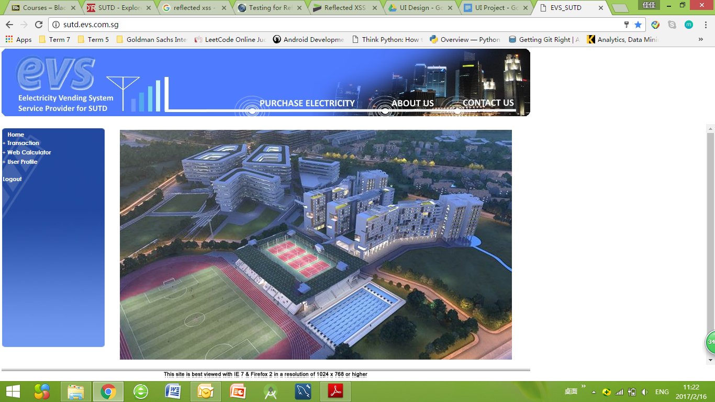

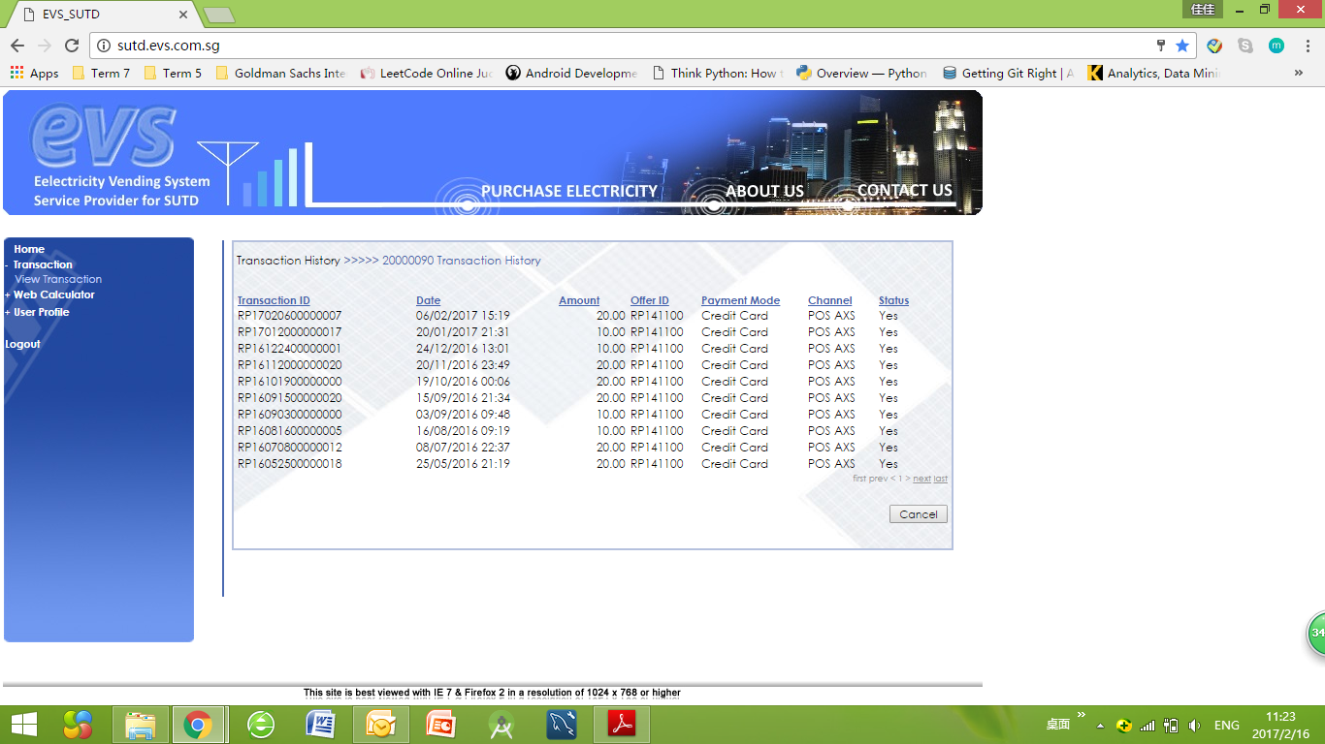

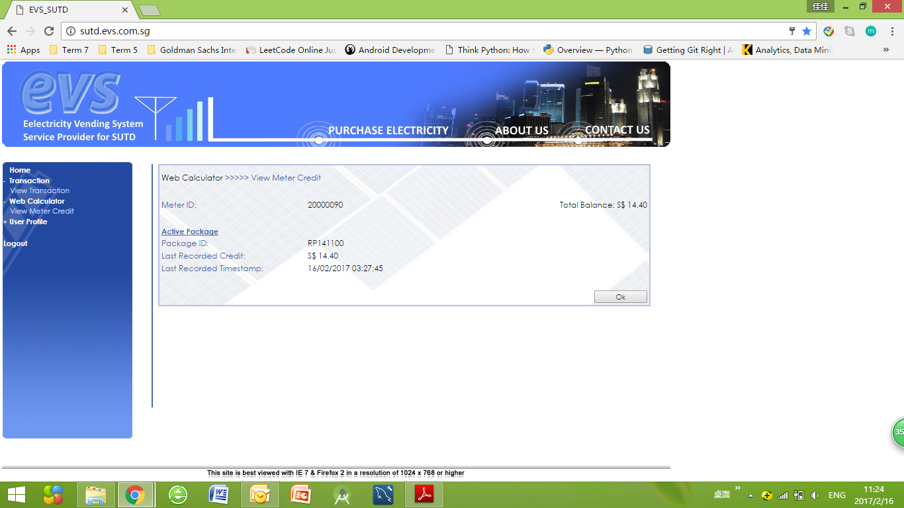

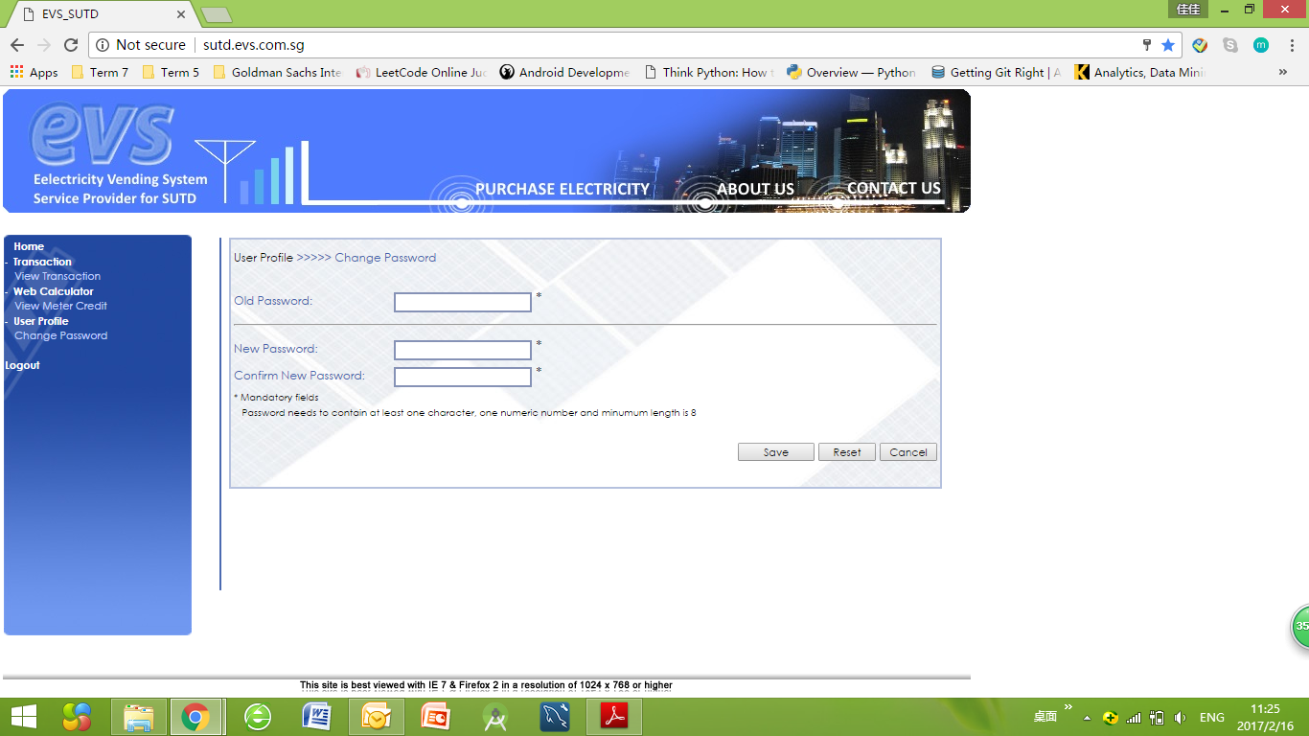

Problem: headers in the left panel are redundant since there is only 1 option beneath it

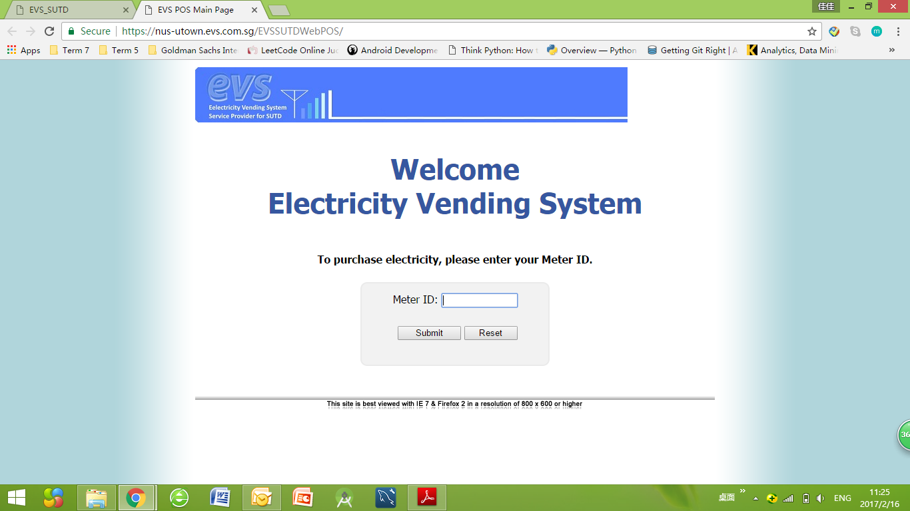

Problem: EVS brings user to a new website and requires user to log in with the same login id and password

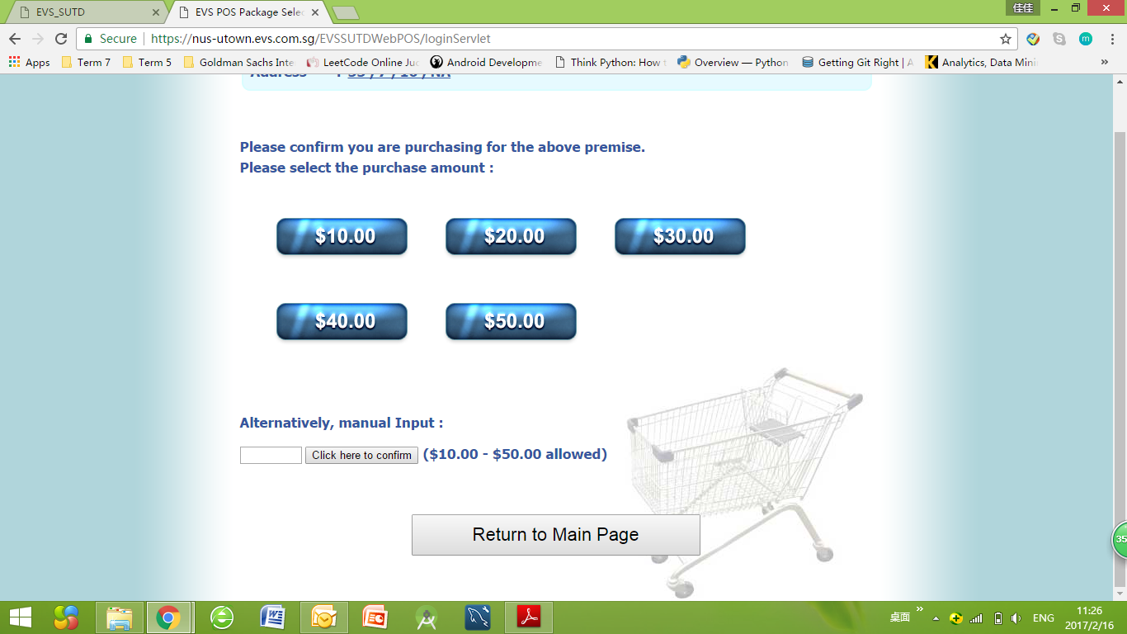

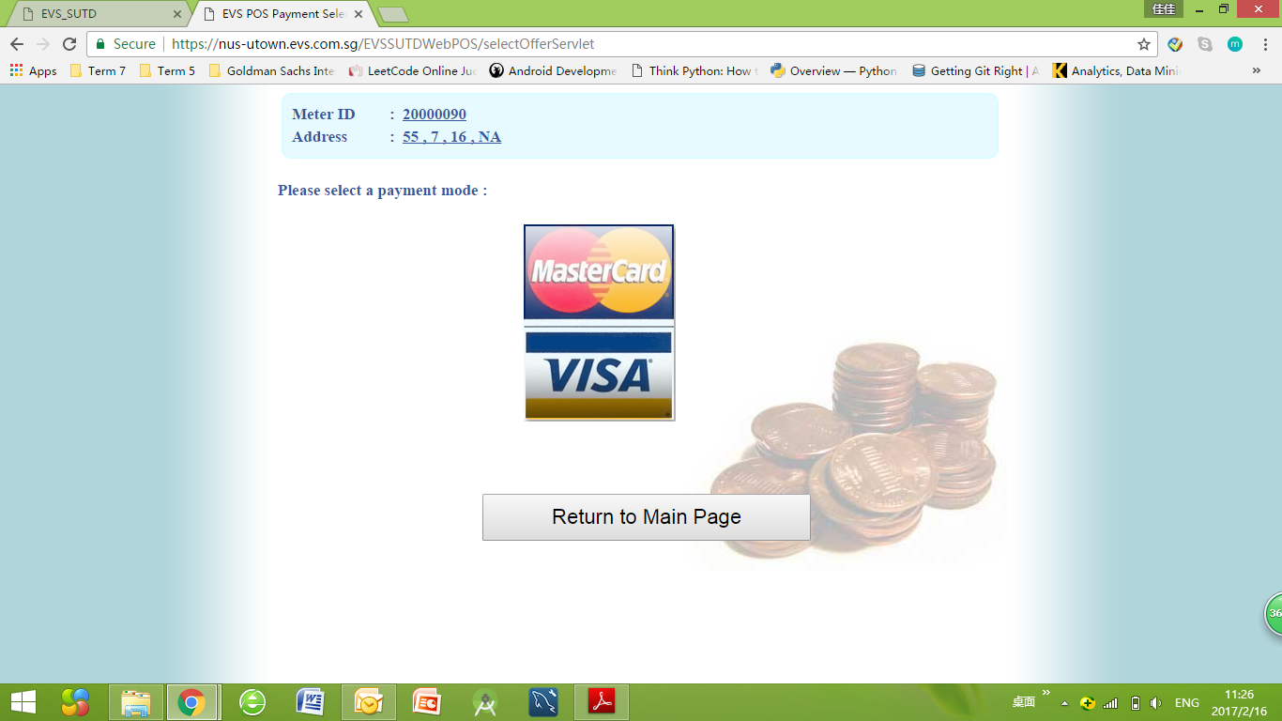

Problem: MasterCard and Visa are one button entirely, this page is redundant.

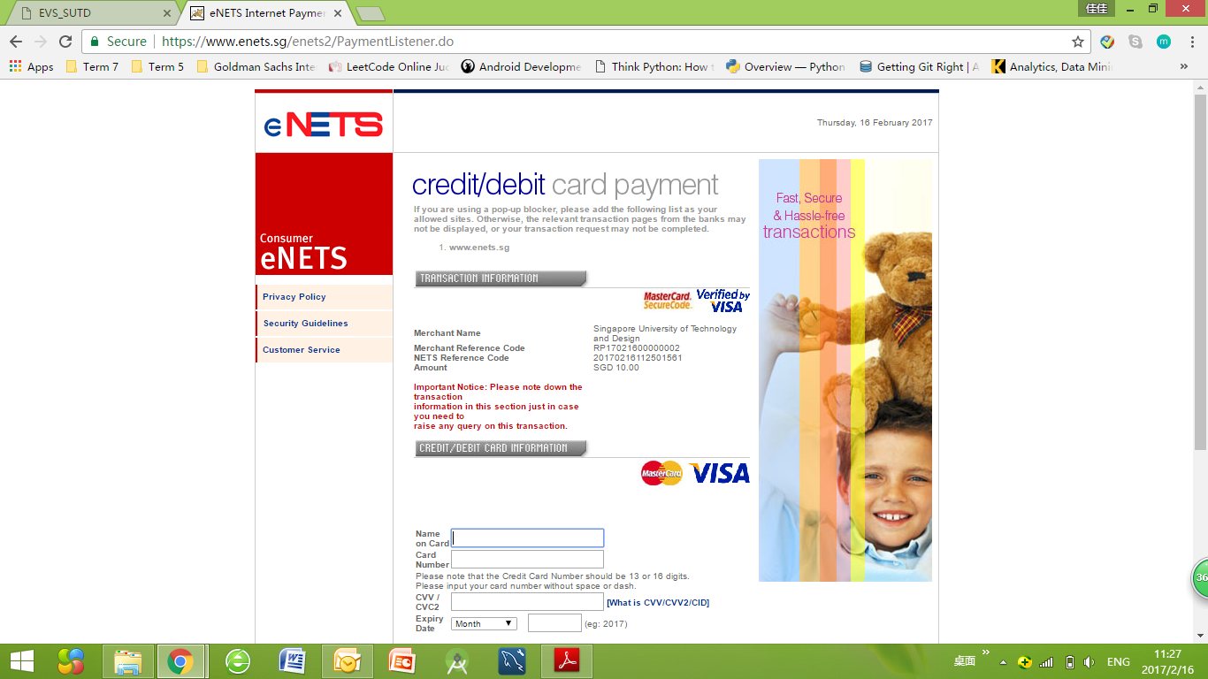

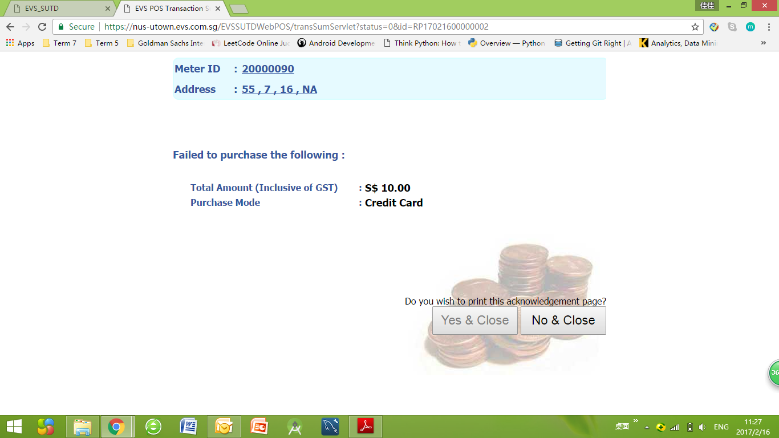

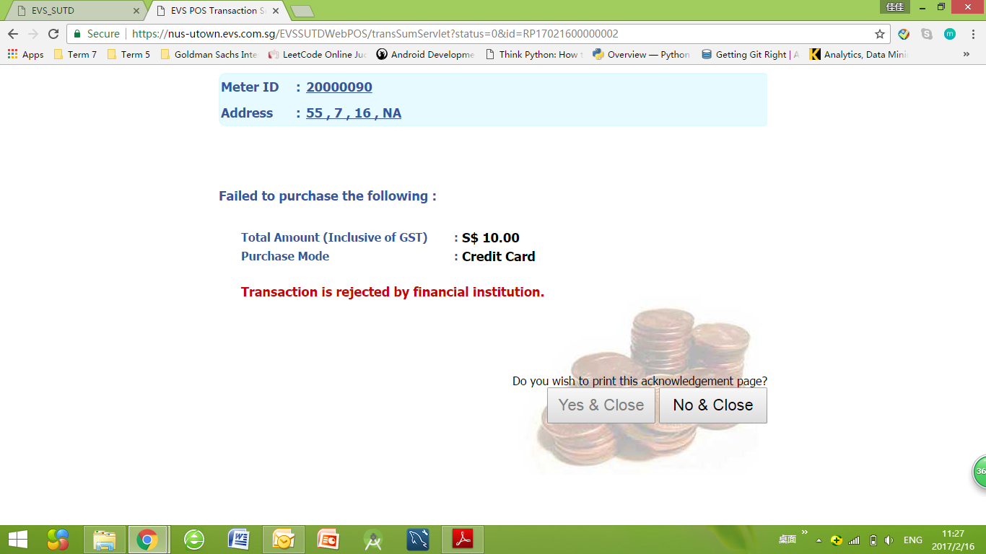

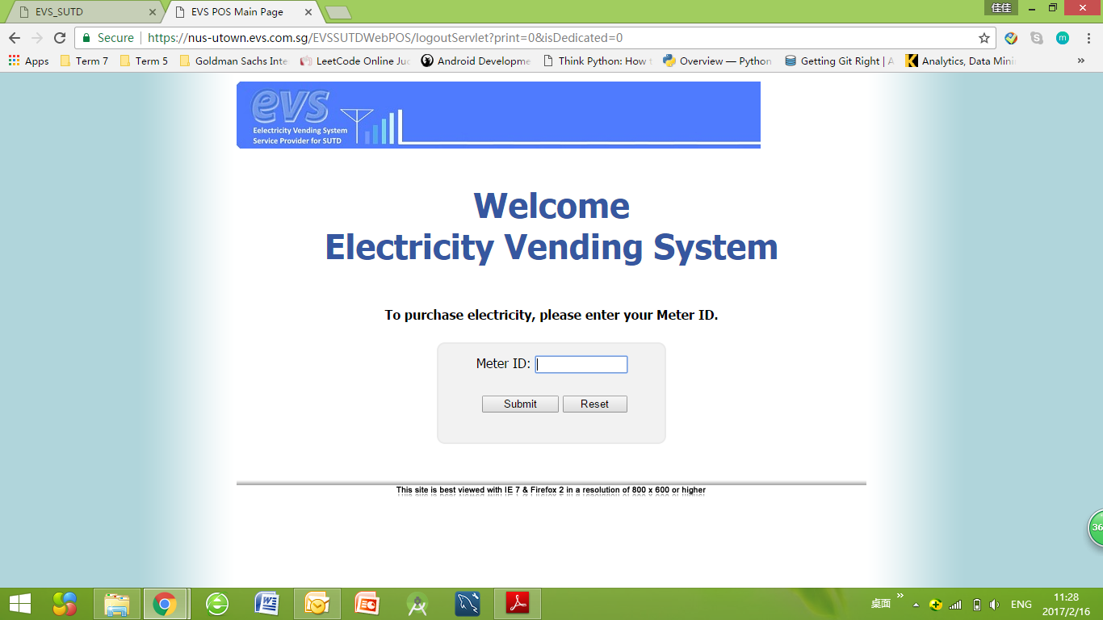

Problem: After clicking ‘No&Close’, website directs user back to this page instead of closing the tab

## myPortal

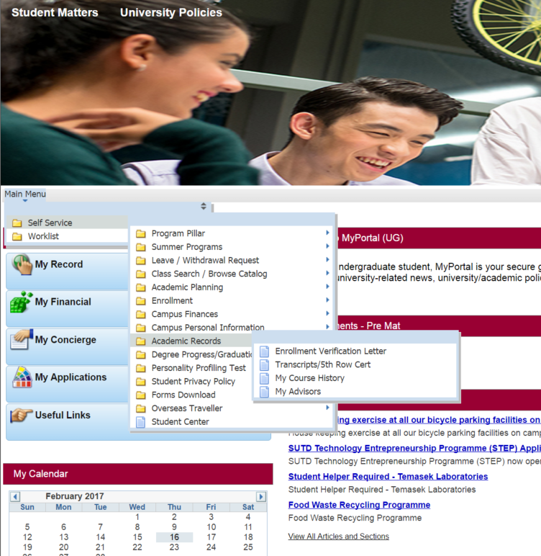

## edimension

if i want to download multiple documents, i need to open everything one by one(can’t even open as a tab).

Long Click distance- i need to open the same content 2 times:

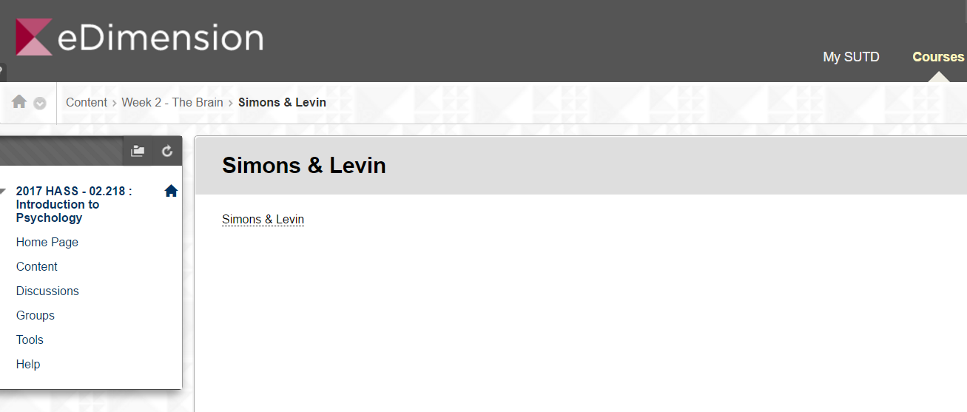

## Housing portal

(hms.sutd.edu.sg)

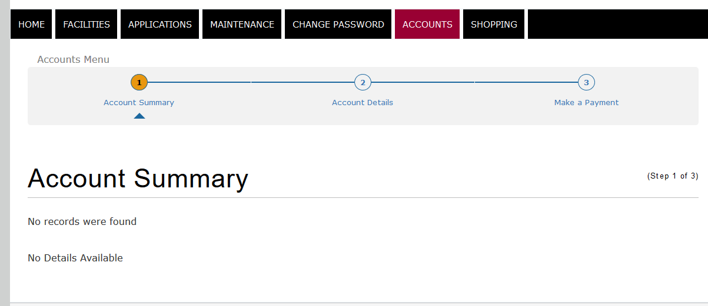

No information contained in the first page. The numbers 1,2,3 in the accounts menu implied sequential order. However, there is no ‘next step’ button and actually there is no orders between those pages.

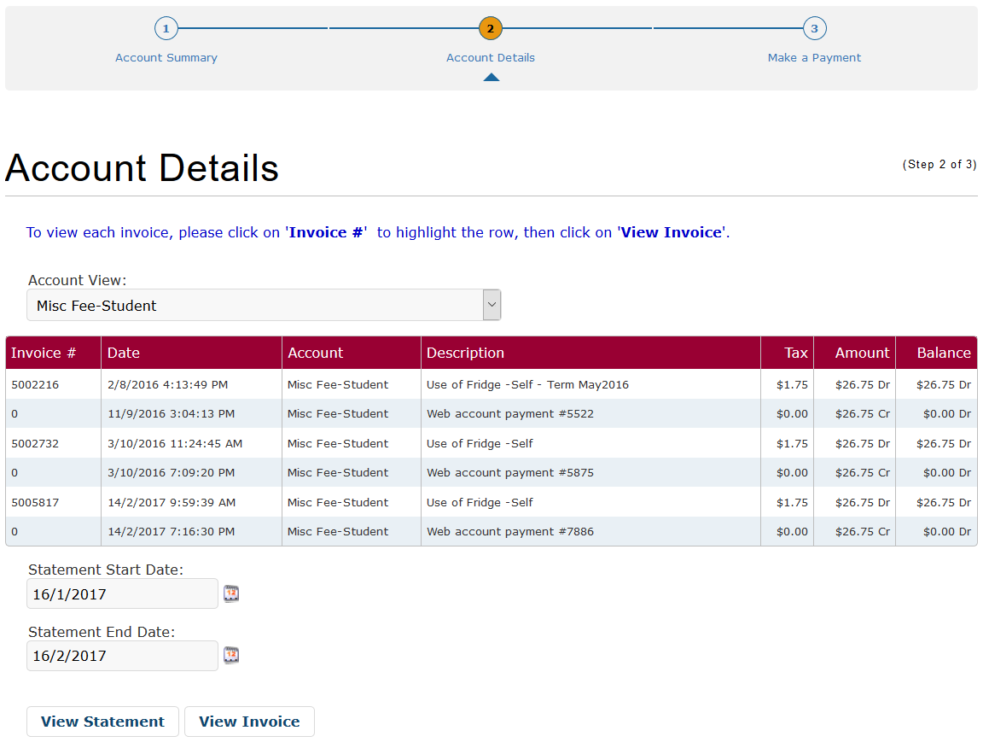

Paid bill and unpaid bill are mixed together. Users cannot directly find which bills are not paid yet. Invoice number 0 is confusing.

Default statement date doesn’t fit the list.

## Embassy websites

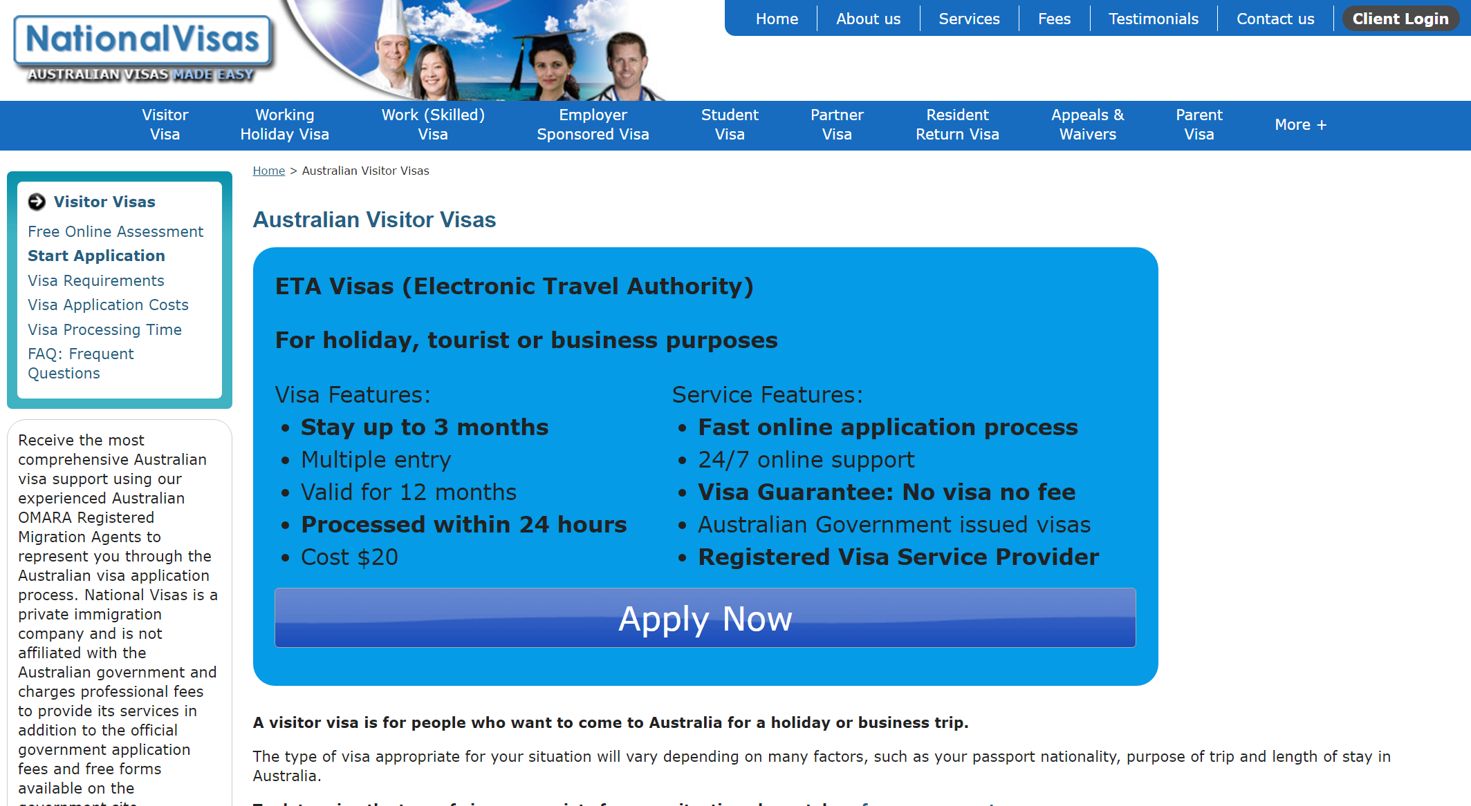

## 

## 

## 

## MOE Tuition Grant

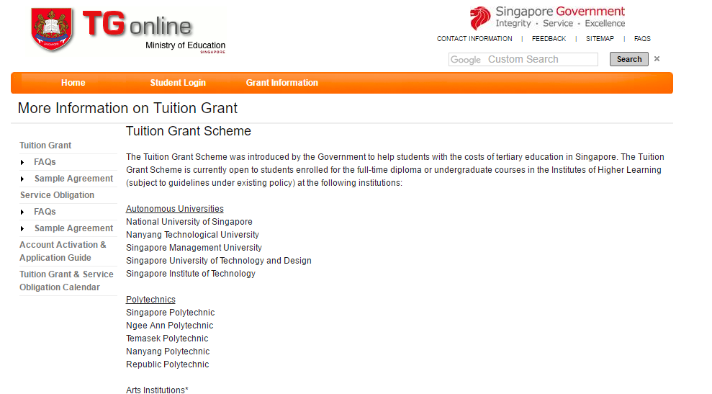

# Screenshots of systems with good UI- utility website / literature review:

## M1 -- numbered steps that clearly shows how to top up

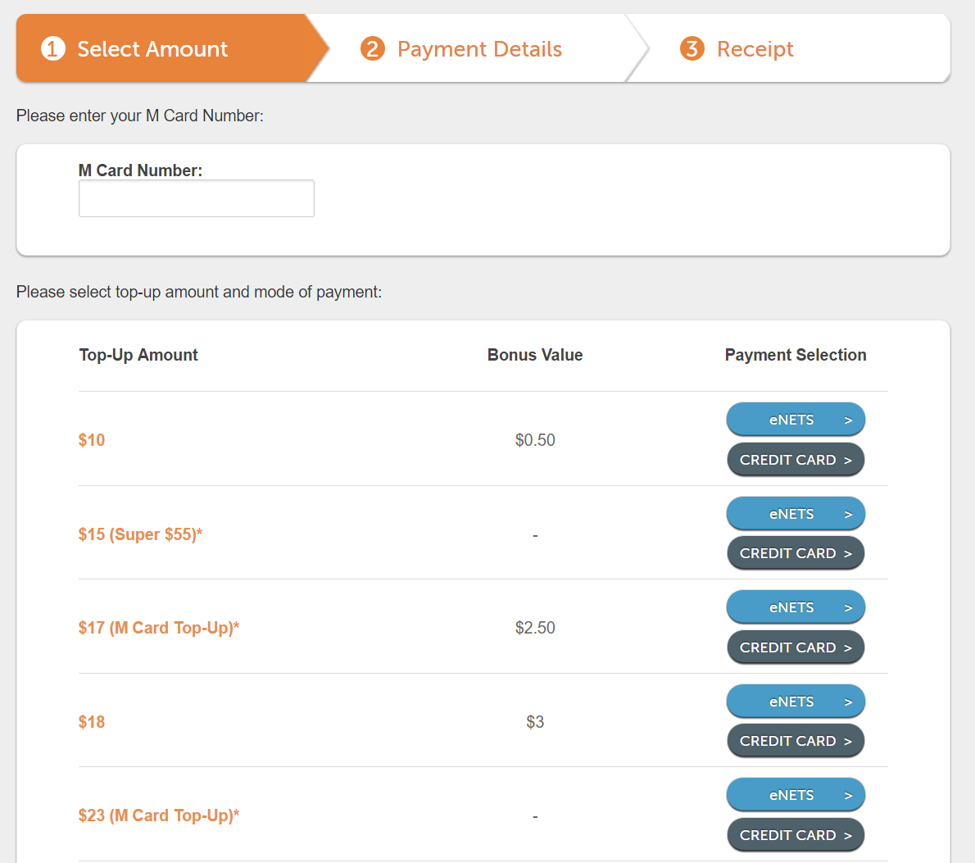

(https://topup.m1.com.sg/enet/topup.jsp#)

## SingTel online top up:

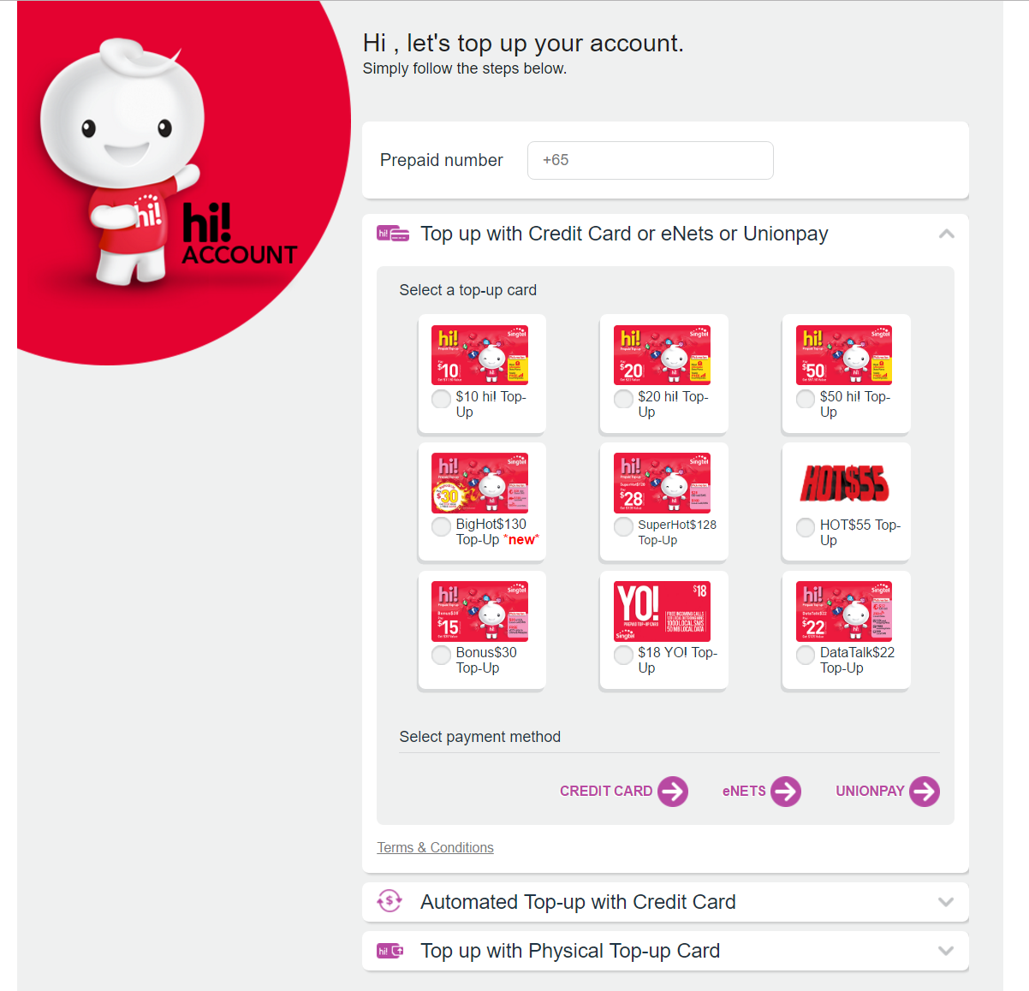

(<https://hi.singtel.com/gotoTopUp.do>)

## New Zealand Visa

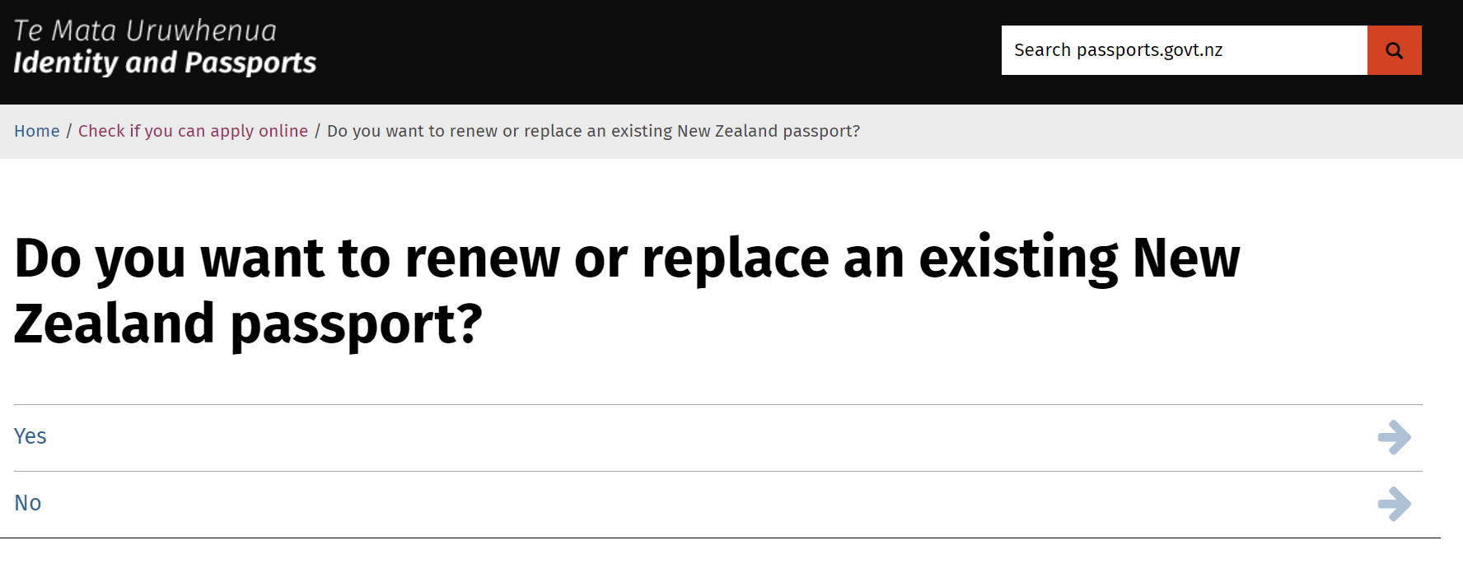

(<https://www.passports.govt.nz/decisions/have-you-or-your-child-had-a-new-zealand-passport-before/>)

## ICA website(singapore immigration)

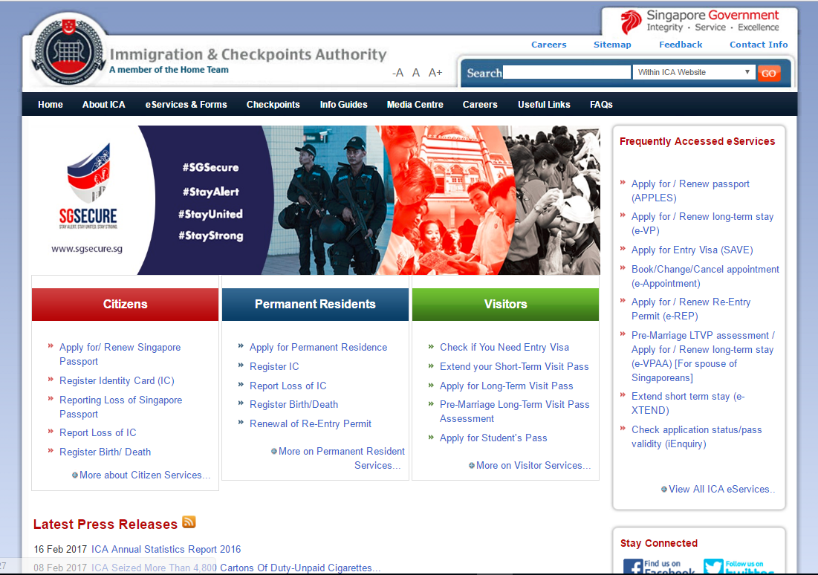

## Sutd.edu.sg

Audiences are listed out on the top right corner,

However it is not obvious due to the background colours and small fonts.

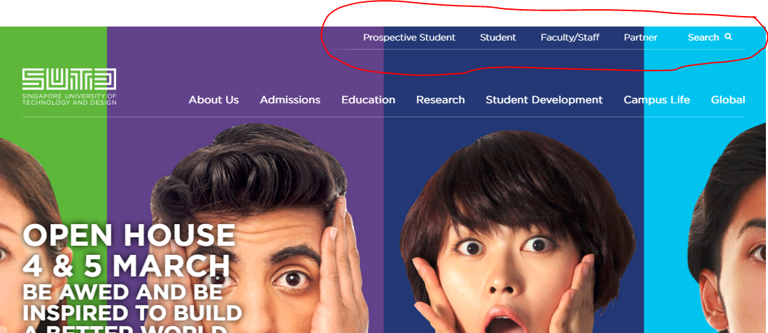

## Usability Evaluation

|  |  |  |  |
| --- | --- | --- | --- |
| **Observation Technique** | **Evaluation Method** | **Test Objective** | **Test Metrics** |
| **Contextual interviews:**  watch how user navigates in their natural environment, silent observation at the side | First-click Testing | * Examines what a test participant would click on first on the interface in order to complete their intended task * Observe how users navigate in their natural work/home setting * Measures:   + Information visibility   + Ease of navigation etc | **Measurable Outcomes:**  Successful Task Completion  Critical Errors  Non-critical Errors  Error-free Rate  Time on Task  **Subjective measures:**  Likes, Dislikes and Recommendations |
|  | Scenarios | * Check if user is able to complete the tasks under different COMMON scenarios |

https://www.usability.gov/how-to-and-tools/methods/planning-usability-testing.html

|  |  |  |  |
| --- | --- | --- | --- |
|  |  | |  |
|  |  |  |  |
|  |  |  |  |
|  |  |  |
|  |  |  |
|  |  |  |
|  |  |  |

Planning- Usability Evaluation Metrics

|  |  |  |  |  |
| --- | --- | --- | --- | --- |
|  | **Priority Level** | **Criteria** | **Measurement Aspect** | **Measurement Technique** |
| **Usability Goals** | 1 | Learnability | Time to learn task (i.e. #f retries required to achieve zero error rate) | Direct Observation |
| 2 | Error Rate | #Errors | Direct Observation |
| 3 | Efficiency | Time to complete task | Direct Observation |
| 4 | Memorability | % of Procedure remembered by users | Questionnaire |
| 5 | Satisfaction | Opinion rating | Questionnaire |
| **UX goals** | 1 | Satisfying | Opinion rating- intuitive, easy to use | Questionnaire |
|  | Observe Facial Expression: Frustrated, Peaceful, Happy etc | Webcam |
| 2 | Enjoying | Ease of Navigation, (Low) Level of Frustration | Questionnaire |
| 3 | Motivating | Time of self-exploration | Direct Observation |
| 4 | Aesthetic | Opinion rating- Layout, Colours & Fonts, etc | Questionnaire |